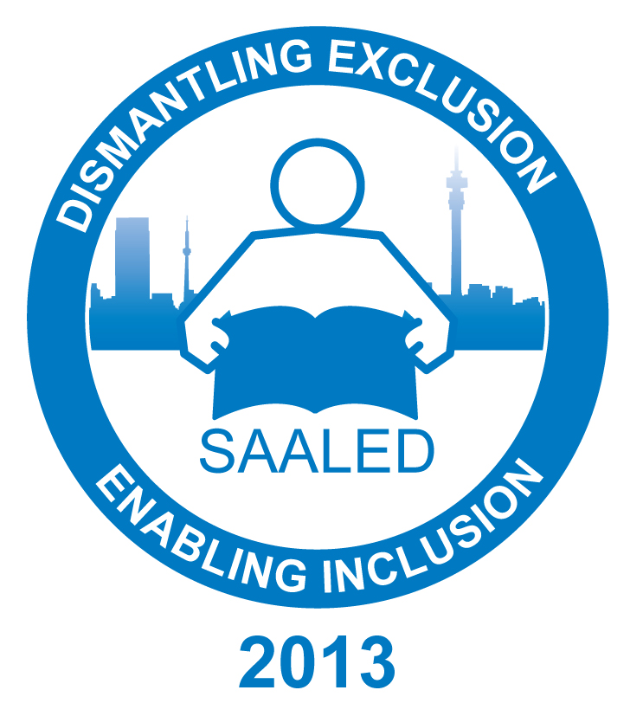

Conference announcement
and first call for papers

Making education inclusive
by
identifying and dismantling exclusionary pressures and practices in education
and considering ways of achieving inclusion

The Southern African Association for Learning and Educational Differences (SAALED) in association with the Unesco Chair in Teacher Education for Diversity and Development at the Wits School of Education announces its biannual conference to be held in Johannesburg from 1 – 6 July 2013.

1 – 3 July will have an academic focus, and students, academics and researchers are invited to submit abstracts of current and completed research for consideration for inclusion in the programme.

4 – 6 July will include various plenary and workshop sessions presented by invited local and international speakers to equip teachers and therapists to meet diverse learning needs.

To submit an abstract for consideration in the academic stream of the conference, please submit the following information online to www.uct-conferences.co.za/saaled/openconf/openconf.php on or after the 15th July 2012.

- Author(s) details, including name, institutional affiliation and all contact details

- Presenter(s) details, including name, institutional affiliation and all contact details. Note: presenters must be registered delegates at the conference. Presenters will be regarded as the correspondents with conference organisers

- An indication of whether the abstract is submitted in support of:
- A seminar presentation of 2 hours that comprises four or more papers/speakers collaborating on a topic.
- An individual paper presentation (30 minutes in total, with 20 minutes for presentation and 10 minutes of discussion).
- A post-graduate student presentation (20 minutes in total, including discussion)
- A poster presentation (current or completed research visually presented, with author/presenter available for discussion with interested delegates)

- An indication of which of the following broad conference themes is applicable to your paper:
- Identifying and addressing exclusionary pressures, policies and practices in education
- The resources and reorganisation of schools required to address educational exclusion
- Teacher education for social justice, inclusion and diversity
- Research-based institutional and classroom strategies to make education inclusive

- The title of your seminar/ paper/ poster

- An abstract of not more than 200 words. (Seminar proposals should include the abstracts of the composite papers of the seminar)

Abstracts will be considered in terms of relevance to conference themes and the extent to which the proposed seminar/paper/poster makes a scholarly contribution to the field of inclusive education.

This first call for papers closes on 30 September 2012. Presenters will be informed of whether their abstracts have been accepted by 31 October. If, after the first call for papers, there is place in the programme for additional presentations, a second call will be made. Fully paid conference registration by presenters is required to secure inclusion in the conference programme.

