## Seminar date and time

**Thursday 5th October 2017**

Start: 9.30am

Finish: 4.30pm

## Venue

**University of Manchester Innovation Centre (UMIC)**

46-48 Grafton Street

Manchester

M13 9XX

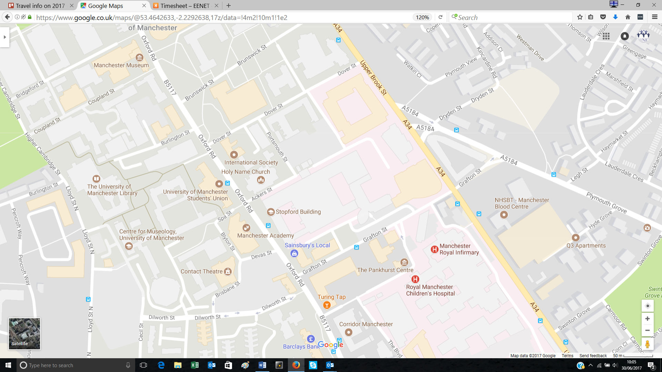

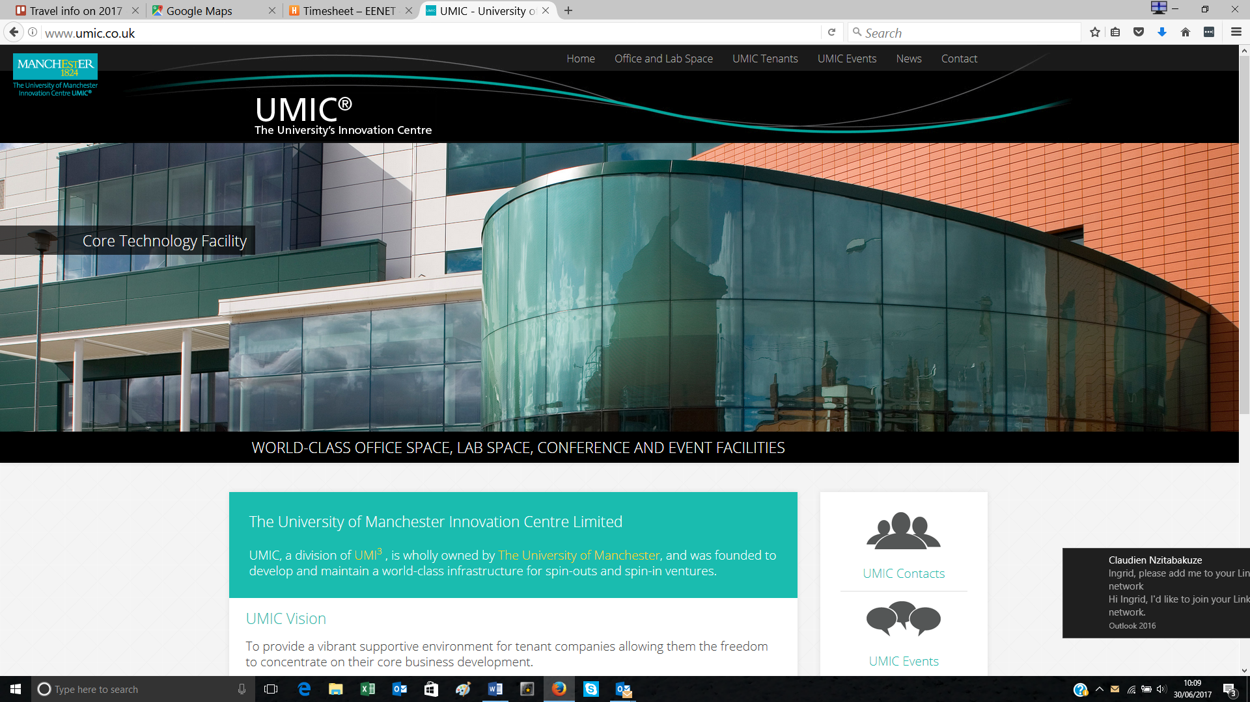

## Getting to the venue

**By train**

* Manchester Piccadilly mainline rail station
  + 25 minutes walk from UMIC
  + 5-10 minutes by taxi – cost is approx. £6
* Manchester Oxford Road mainline rail station
  + 15-20 minutes walk
* Manchester Victoria mainline rail station
  + 40 minutes walk
  + 10-15 minutes by taxi.

For train timetables and prices, visit [National Rail Enquiries](http://www.nationalrail.co.uk/).

**By bus**

* No. 147 shuttle bus runs between Piccadilly station and Grafton Street every 10 minutes on weekdays. See [timetable and route map.](http://www.tfgm.com/journey_planning/RouteMaps/147.pdf)
* The area is well served by other buses, including the numbers 15, 16, 41, 42, 43, 44, 46, 47, 48, 53, 111, 140, 141, 142, 143, 145, 191, 197. Visit [Transport for Greater Manchester](http://www.tfgm.com/buses/Pages/default.aspx) for full details.

**By bicycle**

There are hoop stands for bicycles located outside the UMIC building.

**By air**

* Manchester International Airport is 9 miles from UMIC.
* A direct train from the airport to Manchester Piccadilly station runs every 20 minutes.
* By taxi the journey will take around 20-30 minutes depending on traffic and will cost around £30. You can pre-book a taxi to meet you at the airport. Visit the [airport’s taxi company](https://www.arrowprivatehire.co.uk/airports/manchester/) for a price quote and to book online. Pre-booked taxis are usually cheaper.

**By car**

* The M60 outer ring road connects to all the motorways running into Manchester from north, south, east and west. Motorways within easy reach of the venue include the M60, M61, M62, M602, M56 and M66.

## Parking

There is no parking available for our participants at the venue. Nearby public car parks include:

|  |  |  |  |
| --- | --- | --- | --- |
| **Address** | **Telephone** | **Open** | **Rates** |
| Grafton Street Multi-Storey Car Park (Manchester Royal Infirmary)  Grafton Street  Manchester  M13 9WG | 0161 276 1234 | 24 hours | Up to 30 minutes: Free  Up to 3 hours: £2.50  Up to 6 hours: £5.00  Up to 24 hours: £15.00 |
| Hathersage Road Multi-Storey Car Park  Hathersage Centre  Hathersage Road  Manchester  M13 9WL | 0161 276 1234 | 24 hours | Up to 30 minutes: Free  Up to 3 hours: £2.50  Up to 6 hours: £5.00  Up to 24 hours: £15.00 |
| NCP Aquatic Centre  Booth Street East  Manchester  M13 9SS | 0345 050 7080 | 6am - 12pm | Up to 2 hours: £2.40  Up to 4 hours: £4.10  Up to 9 hours: £5.80  Up to 24 hours: £8.60 |

## Accommodation

We strongly recommend booking accommodation as soon as possible. There is a very large event taking place in central Manchester 1-4 October, which may mean hotels in the surrounding area get booked up quickly.

[**Travel Lodge**](https://www.travelodge.co.uk/hotels/523/Manchester-Upper-Brook-Street-hotel)

227 Upper Brook Street,

Manchester M13 0HB

Tel: +44 (0)8719 846487

* Closest hotel to UIMIC – 10 minute walk
* Average prices approx. £90 per night.

[**Luther King House**](http://www.lutherkinghouse.co.uk/)

Brighton Grove, off Wilmslow Road

Manchester M14 5JP

Tel: +44 (0)161 224 6404

Email: reception@lkh.co.uk

* Peaceful meeting venue with accommodation that EENET has used many times.
* En-suite b&b rooms from £35 per night.
* 25-30 minute walk from UMIC.

[**Holiday Inn Express**](https://www.ihg.com/hotels/us/en/reservation)

2-4 Oxford Rd,

Manchester M1 5QA

Tel: +44 (0)871 423 4931

* Average prices approx. £90 per night
* 15-20 minute walk from UMIC.

[**Hotel Ibis Manchester Centre Princess Street**](https://www.accorhotels.com/gb/hotel-3143-ibis-manchester-centre-princess-street-new-ibis-rooms/index.shtml)

Charles St/Princess St,

Manchester M1 7DG

Tel: +44 (0)161 272 5000

* Average prices approx. £85 per night
* 15-20 minute walk from UMIC.

[**The Principal Manchester**](https://www.phcompany.com/principal/manchester-hotel/?utm_source=google&utm_medium=local&utm_campaign=localSEO)

Oxford St,

Manchester M60 7HA

Tel: +44 (0)161 288 1111

* Prices from £145 per night
* 20 minute walk from UMIC.

[**Airbnb**](https://www.airbnb.co.uk/)

There are many Airbnb rooms available throughout Manchester, with prices usually starting from around £20 per night.

**Organiser contact details**

For any queries about EENET’s seminar:

Email: Kerry Tilden on [kerrytilden@eenet.org.uk](mailto:kerrytilden@eenet.org.uk)

Call/SMS: Ingrid Lewis on +44 (0)7929 326 564