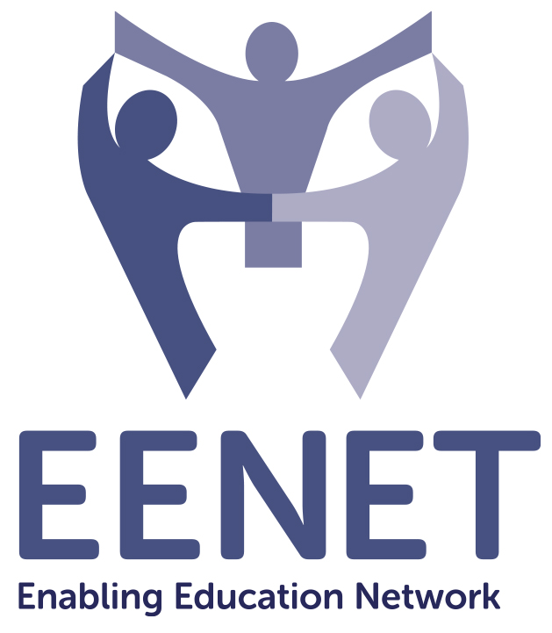
Call for Articles
Enabling Education Review
Issue 13

Information and communication technology and other assistive technologies have the potential to impact social and educational inclusion so the theme for Issue 13 of Enabling Education Review will be:

“Inclusive EdTech”

The deadline for submitting first drafts of articles is 30 September 2024. Details of suggested topics and how to submit articles are provided below.

Contact info@eenet.org.uk with any questions.

1. Why have we chosen this topic?

Increasingly, Education Technology or EdTech is used to support the educational inclusion of children with and without disabilities, including those who are neurodiverse or have other learning difficulties. EdTech is used to describe the combination of computer hardware, software (or information and communication technology and assistive technology) with educational theory and practice to facilitate learning for education purposes. As such, EdTech can complement face-to-face inclusive pedagogy and enable inclusive remote teaching and learning, both at the school level and in teacher training.

ICT and assistive technology innovations in distance education grew during the COVID-19 pandemic but were often not made accessible and did not benefit everyone. EENET’s own survey of home learning in 2020 showed that children with disabilities, children in low-income settings and other marginalised groups of learners were more likely to be excluded as digital innovations advanced. Existing inequalities were made worse.

To help meet the Sustainable Development Goal of ensuring inclusive and equitable quality education for all learners, we need to reflect on how ICT can be made more affordable, appropriate and accessible. We need to explore the challenges and opportunities of using ICT and other assistive technologies within inclusive education in low- and middle-income contexts. We cannot say that ICT is too expensive and will never be used in poorer contexts. Rather we need to ask: How can it become a viable and valuable tool in the inclusive education toolbox for every country? And, in using the phrase Education technology (EdTech) we recognise that providing the technology on its own is only a partial solution at best, and often a missed opportunity.

2. What could you write about?

This issue of EER will explore how ICT and assistive technologies can be used to support learning and teaching in inclusive settings. There are many aspects of EdTech that you could write about, including but not limited to:

- How have approaches to teaching and learning changed and become more inclusive because of the use of ICT?
- How were ICT and other assistive technologies used to support learners transitioning back into schools after COVID-19 closures? What could this tell us about using ICT and assistive technology to support other educational transitions?
- As a learner, how has the use of EdTech impacted your educational experience?
- As a teacher, how have you reached and supported all your learners using EdTech? What challenges and opportunities have you experienced? Who has helped you?
- What impact does the accessibility or inaccessibility of ICT and the use of assistive technology have on peer-to-peer relationship in classrooms?
- How are teachers trained to use ICT and assistive technologies? How are their trainers trained? What professional development programmes are most effective and what else is needed?
- What has worked well in financing the adaptations and use of ICT and assistive technology in inclusive settings in low- and middle-income contexts? What has worked well in sustaining the use of ICT and assistive technology?
- What policies and regulatory frameworks support the integration of EdTech in inclusive education?
- How have you advocated at the local or national level for better or more inclusive digital approaches to education?
- How have you developed partnerships to coordinate the effective use of EdTech in inclusive education?
- How have you motivated or supported a strong political commitment to using EdTech in inclusive education?
- How have you used EdTech to support learners who learn at home on a regular basis? What innovations or changes emerged from the experiences of widespread home learning during the COVID-19 pandemic?
- How has the use of EdTech affected the mental and/or physical well-being of learners, parents, families, and teachers? What has been done to support them?
- How can Artificial Intelligence (AI) help to create more inclusive learning environments? What advancements have already happened and what opportunities are around the corner? What are the benefits, challenges and risks?
- How will the advancement of Artificial Intelligence (AI) impact inclusion of learners with disabilities in education?
- What lessons have we learned that could improve the use of EdTech in the design and inclusivity of education systems long term?

Enabling Education Review helps people share and learn from each other’s experiences. Therefore, we welcome articles that offer practical insights to help others looking for ideas that they can adapt and try. We like articles that provide a little background to the context, project or programme and then explain the activities that happened (what, where, when, with or by whom, and why). We also like to read about the results, if possible.

3. How can you submit an article?

Please email your article to info@eenet.org.uk or send a hard copy to the address at the end of this document.

Authors can write in English or their preferred language.

Length – 550 words (for a single-page article) or 1,100 words (for a double-page article). We may edit longer articles down to a single page, depending on the quantity and quality of articles received.

Style

Write an article: please keep the article easy to read and non-academic. We encourage the use of sub-headings, bullet lists, simple diagrams, etc. Have a look at previous editions of the publication if you are not sure what style to use: www.eenet.org.uk/enabling-education-review/

Write a poem: we encourage you to be creative with your submissions, so if you prefer to write a poem rather than an article, that’s great.

Present a drawing: if you feel that the story you wish to tell is better told visually, please feel free to submit a picture rather than an article. Please give your drawing a title. You could also write and submit a shorter piece of writing that explains the drawing.

Editing – we are happy to help edit the article, so don’t worry if you are not an experienced writer. We can work with you to improve the structure and content of your article, make it shorter/longer, etc.

Working in audio – if you would like to send us a voice recording of your article or be interviewed as the basis for an article, please contact Su Corcoran at info@eenet.org.uk to discuss options.

Photos – it is great if you can add photos, drawings or diagrams to your article. When selecting photos, please look for the following:
- Active images – e.g., children learning in groups, children playing, teachers/ parents working with learners, and so on;
- Images that are not too dark, blurred, or pixelated.

Please send us high-resolution images by email (these should be at least 1MB in size), or post us an original print/drawing. For every image you want to add to your article, you will probably need to remove about 75-100 words of text – but we can help with this editing.

Permission
Please ensure that the people in any photos have given their permission for the photos to be published, or that parents/guardians have given permission for photos of children or vulnerable adults to be used.

Please fill in and send us the permission form (below) attached to your photo(s).

Deadline – the first deadline for draft submissions is 30 September 2024. We will then review all articles and work with the authors to edit them.

Selection – please note that we might not publish all of the articles we receive. In addition to ensuring that we publish articles that are easy to read and of practical use to a range of education stakeholders, we will also ensure that the final selection includes:
- articles from a variety of countries/regions;
- articles about a range of different issues;
- articles by authors from different backgrounds.

Articles not selected for publication in EER may instead be published on EENET’s website (www.eenet.org.uk).

Queries – if you have any questions, please email info@eenet.org.uk.

Postal address – if you want to send an article in hard copy or as an audio recording (e.g., on CD or flashdrive), please send it to:

EENET
PO Box 422
Hyde
Cheshire, SK14 9DT, UK

Permission form – Enabling Education Review

Please fill in a form for each photo you want us to publish. Please also fill in a form if you name people in a case story and have chosen not to change their names.

Name of person submitting the article to EENET:

Title, file name or description of photo:

Name of person in photo / story (delete as applicable):

Parent / guardian’s name (if person in photo/story is under 16):

I understand that my / my child’s photo / story may be published in EENET’s Enabling Education Review, in printed copy and online.

I also understand my / my child’s photo / story may be shared through other media, such as social media.

I understand that once the photo / story is published and shared online, it will not be possible to remove it in future.

I give my permission for my / my child’s photo / story to be used in these ways.

Signature:

Date:

Contact details (e.g. tel no, email, address):

